# Task 3

1. Write a SQL query to Find the average account balance for all customers.

Query:

SELECT AVG(balance)

FROM accounts;

Output:

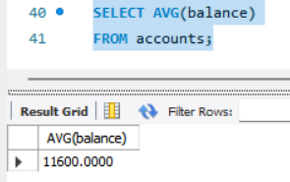

1. Write a SQL query to Retrieve the top 10 highest account balances.

Query:

SELECT * FROM accounts

ORDER BY balance

LIMIT 10;

Output:

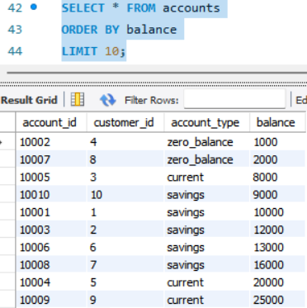

1. Write a SQL query to Calculate Total Deposits for All Customers in specific date.

Query:

SELECT SUM(amount) AS Total Deposits

FROM transaction

WHERE transaction_type=’deposit’

AND transaction_date=’2024-04-08’;

Output:

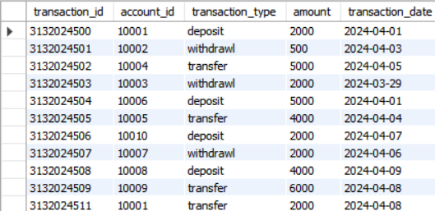

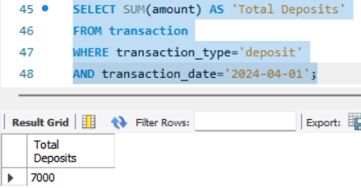

1. Write a SQL query to Find the Oldest and Newest Customers.

Query:

SELECT MIN(join_date) AS Oldest customer, MAX(join_date) AS Newest customer

FROM customers;

Output:

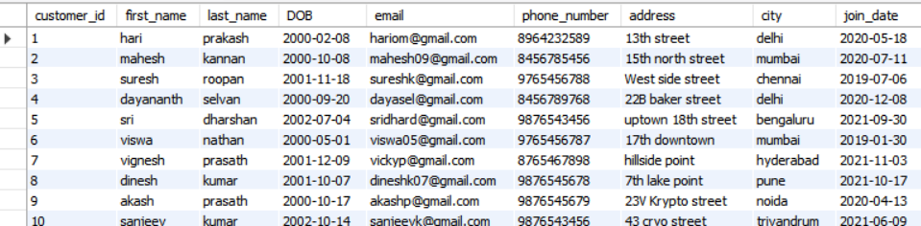

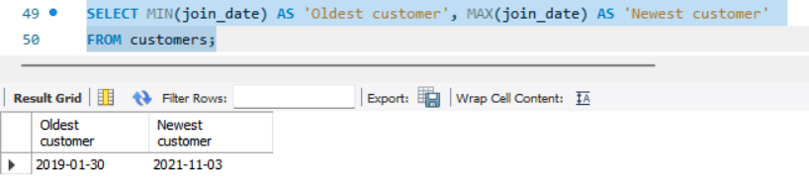

1. Write a SQL query to Retrieve transaction details along with the account type.

Query:

SELECT T.transaction_id, T.transaction_type,T.amount,T.transaction_date,

A.account_type

FROM transaction T

RIGHT JOIN accounts A

ON T.account_id=A.account_id

ORDER BY account_type;

Output:

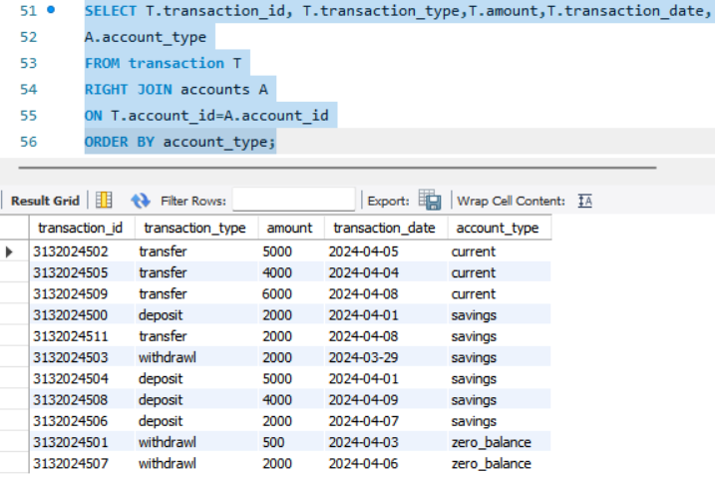

1. Write a SQL query to Get a list of customers along with their account details.

Query:

SELECT C.customer_id, CONCAT(first_name,last_name) AS name, A.account_id,A.account_type,A.balance

FROM customers C

JOIN accounts A

ON C.customer_id=A.customer_id

ORDER BY C.customer_id;

Output:

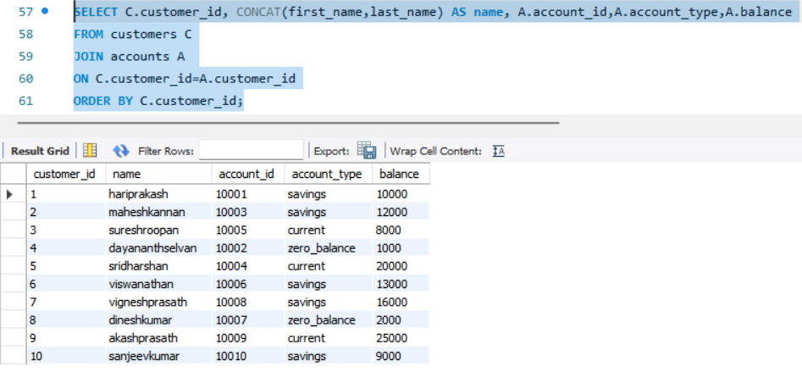

1. Write a SQL query to Retrieve transaction details along with customer information for a specific account.

Query:

SELECT C.customer_id,CONCAT(C.first_name,C.last_name)

AS name,T.transaction_id,T.account_id,T.transaction_type,

T.amount,T.transaction_date

FROM transaction T

JOIN accounts A ON T.account_id=A.account_id

JOIN customers C ON A.customer_id=C.customer_id

WHERE A.account_id=10001;

Output:

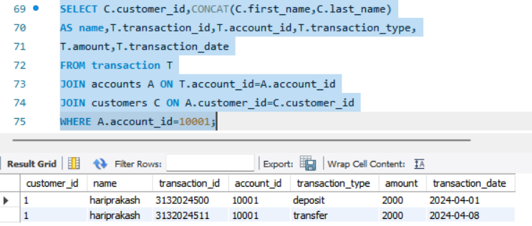

1. Write a SQL query to Identify customers who have more than one account.

Query:

SELECT customer_id,COUNT(*) AS 'Count'

FROM accounts

GROUP BY customer_id

HAVING COUNT(*)>1;

Output:

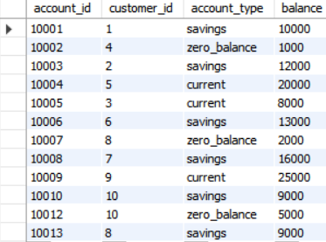

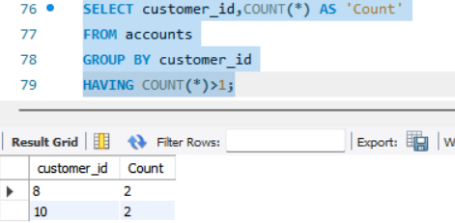

1. Write a SQL query to Calculate the difference in transaction amounts between deposits and withdrawals.

Query:

SELECT

SUM(CASE

WHEN transaction_type='deposit' THEN amount ELSE 0 END) -

SUM(CASE

WHEN transaction_type='withdrawl' THEN amount ELSE 0 END)

AS total_Difference

FROM transaction;

Output:

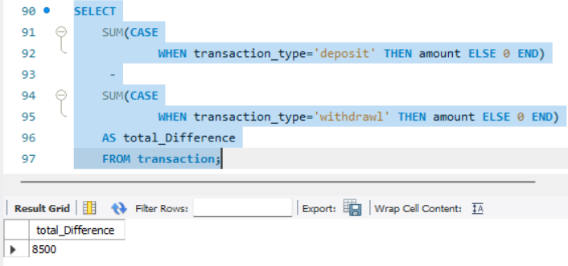

1. Write a SQL query to Calculate the average daily balance for each account over a specified period.

Query:

SELECT account_id,

AVG(amount) AS avg_daily_balance

FROM transaction

WHERE transaction_date BETWEEN '2024-04-01' AND '2024-04-03'

GROUP BY account_id;

Output:

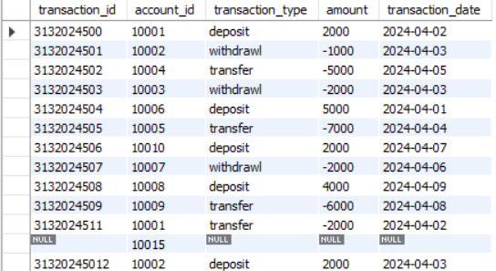

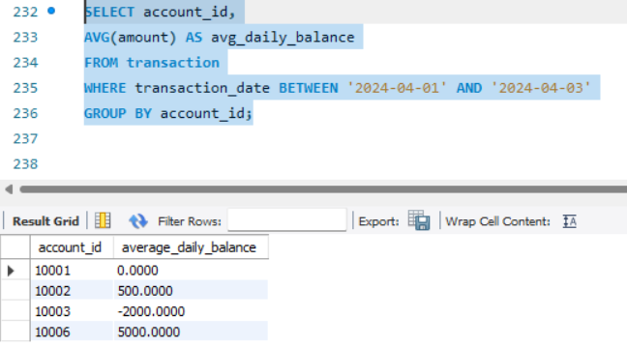

1. Calculate the total balance for each account type.

Query:

SELECT account_type, SUM(balance) AS ‘total balance’

FROM accounts

GROUP BY account_type;

Output:

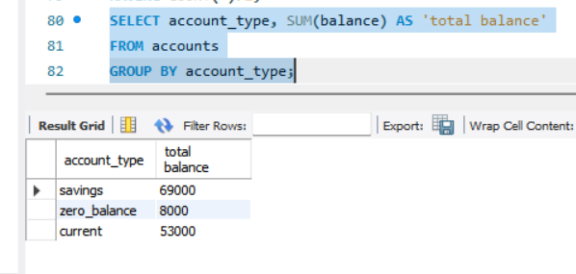

1. Identify accounts with the highest number of transactions order by descending order.

Query:

SELECT account_id, COUNT(*) AS ‘count’

FROM transaction

GROUP BY account_id

ORDER BY ‘count’ DESC;

Output:

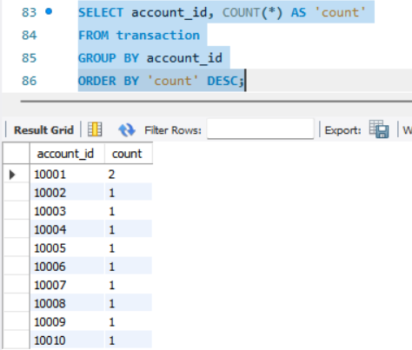

1. List customers with high aggregate account balances, along with their account types.

Query:

With TotalBalance AS(

SELECT customer_id, SUM(balance) AS tot_bal

FROM accounts

GROUP BY customer_id)

SELECT C.customer_id, CONCAT(C.first_name,C.last_name)AS name,

A.account_type,T.tot_bal

FROM customers C

JOIN TotalBalance T

ON C.customer_id = T.customer_id

JOIN accounts A

ON A.customer_id=C.customer_id

WHERE tot_bal>15000;

Output:

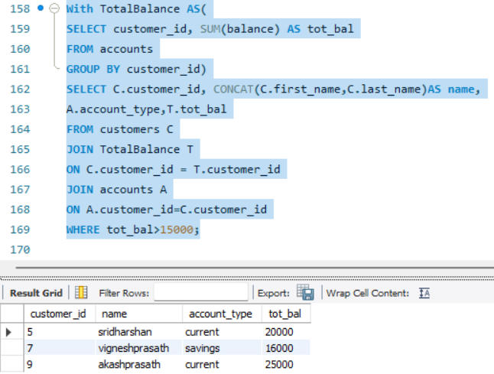

1. Identify and list duplicate transactions based on transaction amount, date, and account.

Query:

SELECT account_id, amount, transaction_date ,COUNT(*) AS dupcount

FROM transaction

GROUP BY amount, transaction_date, account_id HAVING COUNT(*) > 1;

Output:

